Heart of America Chapter Scholarship Application
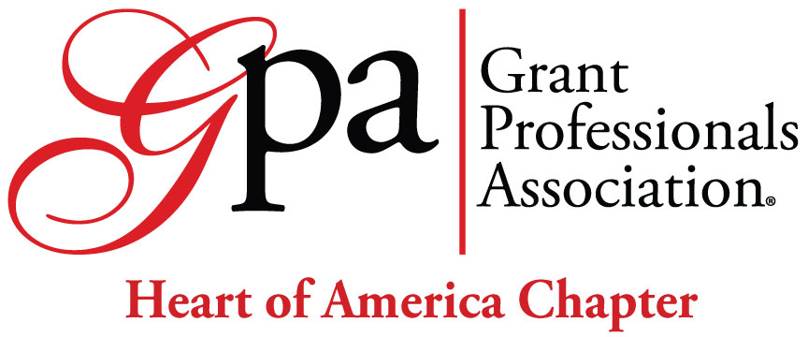

Applications are due by midnight on Friday, May 10th. Awardees will be notified by June 14th.

Applicant Contact Information

Name:
Organization:
Email Address:
Street Address:
City:
State:
Zip:
Preferred Phone (Day):
(Evening):

How will you attend GrantSummit? Virtual In Person

This is an application for:
Full Scholarship Amount: $___________________________
Partial Scholarship Amount: $___________________________
Student Scholarship Amount: $___________________________
(Rates are found on the GPA GrantSummit webpage. This scholarship is for Early Bird fees.)

BACKGROUND AND EXPERIENCE (20 Points)

How did you become interested in the grant profession? Describe your experience as a grant professional. (200 Word Limit)

PROFESSIONAL IMPACT (30 Points)

How will attending the conference impact you professionally? What do you hope to get out of GrantSummit? (250 Word Limit)

Contribution to the Profession (25 Points)
Please describe your contribution or planned contribution to the profession. (200 Word Limit)

NEED (20 Points)
Are there financial factors the committee should consider when reviewing your application? (200 Word Limit). For example, has your employer instituted a freeze on travel so your attendance would be out-of-pocket? Is your employer willing to match a portion of the value of this scholarship? Consultants may wish to indicate whether their business is new and can't support the cost of the conference, or if illness or other factors have reduced your revenue this year, etc.

Are there other factors that the committee should consider when reviewing your application? (200 Word Limit)

OTHER (2 Points) No response required.

As a grant professional, your application should reflect the same standards as a grant proposal being submitted to a funder. Points will be awarded by the reviewers based on the clarity of your responses, spelling/grammar, adherence to instructions, overall presentation of the application, etc.

2024 Grant Summit Criteria | Max. | Min
Background and Experience | 20 | 13
Professional Impact | 30 | 20
Contribution to the Profession | 25 | 15
Need | 20 | 13
Other (clarity, spelling/grammar, following instructions, overall presentation of application, etc.) | 25 | 20
Total | 120 | *81

*Applicants must receive a minimum number of points in each section as scored by the committee to receive the scholarship. If no applicants receive the minimum number of points, funds will be held until the next year.

By submitting an application, I agree to make a presentation on my conference experience and workshops attended no later than the February 2025 Heart of America chapter meeting and/or submit a written summary of my experience.

___________________________________________________________________________
Signature and date

