Grant Professionals Association—Heart of America Chapter
Grant Professionals Association and Chapter Membership Scholarship
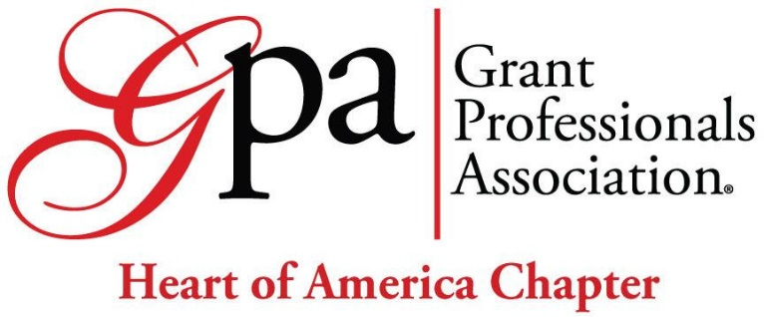

Membership in the international Grant Professionals Association (GPA) and your local chapter allows you to become a part of a professional organization dedicated to grant professionals. Membership is open to any individual with an interest in and commitment to the grants profession. Become a member for education, resources, and networking! For a full description of membership benefits and opportunities, visit the GPA Membership webpage and GPA Chapter webpage. For technical questions about GPC membership, please email staff@grantprofessionals.org.
The Heart of America Chapter of GPA is happy to offer 2026 scholarships for NEW membership in international Grant Professionals Association for PROFESSIONAL, STUDENT, RETIREE, and CHAPTER.
If selected, the Heart of America Chapter will coordinate your membership with the Membership Director to advance you to the next step. Please don’t automatically join and pay. The membership scholarships are for NEW members (not renewal).
Eligibility
Applicants must:
- Not have previously received a membership scholarship.
- Be actively involved in, or demonstrate a desire to become actively involved in, the Heart of America Chapter and/or Grant Professionals Association.
- Submit an application with all required information.
Applications that do not meet eligibility threshold will not be considered.
Application Due Date
May 1, 2026, at 6:00 p.m. CT
Please submit any scholarship questions to the Heart of America Chapter Scholarship Committee at heartofamericachapter@grantprofessionals.org.
If no qualified applications are received by the due date, the Heart of America Chapter may provide another scholarship opportunity in the future.

Announcement Date
May 30, 2026, via email or telephone to the successful applicant.
Applicant Information
Date:
Name:
Affiliation (if applicable):
Email address:
Telephone number:
In the Kansas City area: ☐ Yes ☐ No

Request Details
This scholarship application is for NEW Grant Professionals Association and Heart of America Chapter membership. You may select only a primary GPA membership or combined primary GPA and Chapter membership. Please select your level(s):
☐ GPA Professional Member $235
Available for individuals that do not fall in any of the following categories: Student, Entry Level, Retiree, or Legacy.
☐ GPA Student Member $100
Available for individuals who are enrolled as full-time undergraduate students at a college or university or who are enrolled in a graduate program. See eligibility requirements.
☐ GPA Retiree Member $100
Available for individuals who are not working as a grant professional in any capacity [i.e., either part-time or as a consultant]. See eligibility requirements.
☐ Heart of America Chapter Member $25
Available for individuals who are interested in involvement at the local level. To join a Chapter, you MUST also have a primary GPA membership.
Request Description
As a grant professional, your application should reflect a high degree of quality, much like a funding proposal. Please provide clear, compelling statements. Information provided should be responsive to the questions. Being personal and authentic is encouraged (as opposed to generic or AI generated). The review panel may take into consideration spelling, grammar, punction, etc.
Describe your background and experience as a grant professional and your interest in the Grant Professionals Association and Heart of America Chapter. (100 words)

How does association and chapter membership make a personal or professional impact? (100 words)

How will membership benefits and resources allow you to contribute to the field of grantsmanship? Examples may include presenting at conferences, joining professional/networking groups, volunteering/providing pro-bono services, or mentoring early career professionals. (100 words)

Will this scholarship help to address financial or other needs? If so, please describe. (100 words)

Are there additional factors that the committee should consider when reviewing your application? OPTIONAL (50 words)

Scoring criteria
 | Max. | Min
Background and Experience | 20 | 15
Personal or Professional Impact | 30 | 23
Contribution to the Field | 25 | 18
Financial or Other Need | 25 | 15
Total | 100 | *71

