Grant Professionals Association—Heart of America Chapter
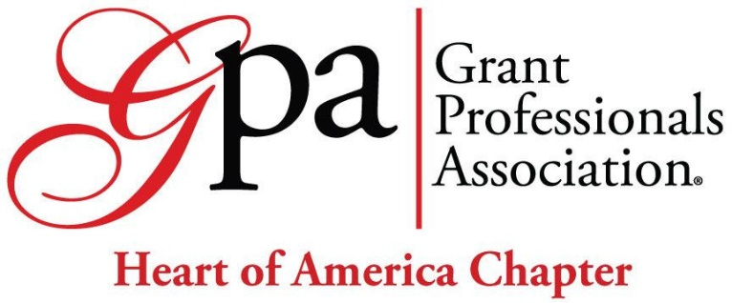
Grant Professional Certified (GPC) Exam Scholarship

Did you know that grant professionals with a strong background in education, experience, professional development, community involvement can become credentialed as a Grant Professional Certified (GPC)? Become GPC-credentialed to demonstrate excellence in the grants profession and establish credibility! To learn more about the accredited Grant Professional Certification Institute (GPCI) and their administration of the Grant Professional Certified (GPC), visit the GPCI Eligibility webpage. For technical questions about GPC eligibility, please email regdocs@grantcredential.org
The Heart of America Chapter of GPA is pleased to offer a 2026 scholarship for the Grant Professional Certified FIRST TIME candidate exam fee of $639.
If selected, the Heart of America Chapter will coordinate your registration with the Certification Institute to advance you to the next step. Please don’t automatically register and pay. The candidate exam scholarship is for FIRST TIME candidates (not retake).
Eligibility
Applicants must:
- Not previously received a candidate exam scholarship.
- Be actively involved in, or demonstrate a desire to become actively involved in, the Heart of America Chapter and/or Grant Professionals Association.
- Submit an application with all required information.
Applications that do not meet eligibility threshold will not be considered for a scholarship.
Application Due Date
May 1, 2026, at 6:00 p.m. CT
Please submit any scholarship questions to the Heart of America Chapter Scholarship Committee at heartofamericachapter@grantprofessionals.org.
If no qualified applications are received by the due date, the Heart of America Chapter may provide another scholarship opportunity in the future.
Announcement Date
May 30, 2026, via email or telephone to the successful applicant.
Applicant Information
Date:
Name:
Affiliation (if applicable):
Email address:
Telephone number:
In the Kansas City area: ☐ Yes ☐ No

Request Details
This scholarship application is for Grant Professional Certified (GPC) FIRST TIME candidate exam fee of $639. Please confirm that you:
Reviewed the Candidate Guide ☐
Completed the Eligibility Survey ☐
Previewed the Eligibility Packet ☐
Commit to taking the GPC Exam ☐
Request Description
As a grant professional, your application should reflect a high degree of quality, much like a funding proposal. Please provide clear, compelling statements. Information provided should be responsive to the questions. Being personal and authentic is encouraged (as opposed to generic or AI generated). The review panel may take into consideration spelling, grammar, punction, etc.
Describe your background and experience in the grant profession. (100 words)

How will obtaining your Grant Professional Certified (GPC) make a personal or professional impact? (100 words)

In what ways will you contribute to the field of grantsmanship after achieving your Grant Professional Certified (GPC)? Examples may include presenting at conferences, joining professional/networking groups, volunteering/providing pro-bono services, or mentoring early career professionals. (100 words)

Will this scholarship help to address financial or other needs? If so, please describe. (100 words)

Are there additional factors that the committee should consider when reviewing your application? OPTIONAL (50 words)

Scoring criteria
 | Max. | Min
Background and Experience | 20 | 15
Personal or Professional Impact | 30 | 23
Contribute to the Field | 25 | 18
Financial or Other Need | 25 | 15
Total | 100 | *71

